

**Introdcution to web technologies**

**Deployment of Website using AWS**

Teacher:

Nataliia Strukalo

Student:

Ahmed Mohammed Alkali

Album number:

W66986

Rzeszów 20203

TABLE OF CONTENTS

1. Description of topic, and objectives
2. Steps used in order to deploy website on aws
3. Pictures of steps performed
4. Description of technology used
5. Literature used

**Description of topic, and objectives**

### Description

Deploy of website on a cloud platform

I created a website about my favourite comic book franchise and i hosted it on aws using S3

### Steps

1. Choose a cloud provider: Select a cloud platform that suits your needs in this case its Amazon Web Services (AWS)
2. Create an account on the chosen cloud provider's website.
3. Configure your web server: Prepare your website's code and dependencies. For example, if you have a website built with HTML, CSS, and JavaScript, make sure your files are organized and ready for deployment. Choose a hosting service: Select a hosting service offered by your cloud provider. AWS offers Amazon S3 (Simple Storage Service) for static websites .These service allow you to store and serve your website files.
4. Upload your website files: Use the cloud provider's interface or command-line tools to upload your website files to the hosting service. This typically involves creating a container or bucket and transferring your files to it.
5. Configure DNS and domain: If you have a custom domain name, you'll need to configure DNS settings to point your domain to your cloud provider's hosting service. This step ensures that your website is accessible via your desired domain name.
6. Test and verify: Once your website is uploaded and the DNS configuration is complete, test your website by visiting the domain. Ensure that all the pages and functionality work as expected.

### Steps used with S3 bucket on aws

1. Create an S3 bucket: Once you have an AWS account, navigate to the Amazon S3 service. Click on "Create bucket" and provide a unique name for your bucket. Select the region closest to your location and leave the default settings for the rest of the options.
2. Enable static website hosting: After creating the bucket, select it from the S3 bucket list. Go to the "Properties" tab and click on "Static website hosting." Choose the "Use this bucket to host a website" option.
3. Configure index and error documents: Specify the index document (e.g., index.html) and error document (e.g., error.html) for your website. These files will be served when visitors access your website.
4. Upload your website files: In the bucket's overview page, click on the "Upload" button to upload your website files. You can drag and drop your files or choose them from your local machine. Make sure to include your HTML, CSS, JavaScript, and any other necessary files.
5. Set permissions: Select the uploaded files, go to the "Actions" dropdown menu, and choose "Make public." This allows the files to be accessible to visitors.
6. Test your website: Once the files are uploaded and set to public, AWS will provide a website endpoint URL. Copy the URL and open it in a web browser to verify that your website is working correctly.
7. Configure DNS and domain (optional): If you have a custom domain, you can configure it to point to your AWS S3 website. AWS Route 53 is the DNS service that can be used for this purpose. Follow the AWS Route 53 documentation to set up your domain and configure the necessary DNS settings.
8. Finally : if you click on this link it takes you directly to the website: https://dcufansite.s3.eu-north-1.amazonaws.com/myp/myp.html

## Picutures of the steps menitoned

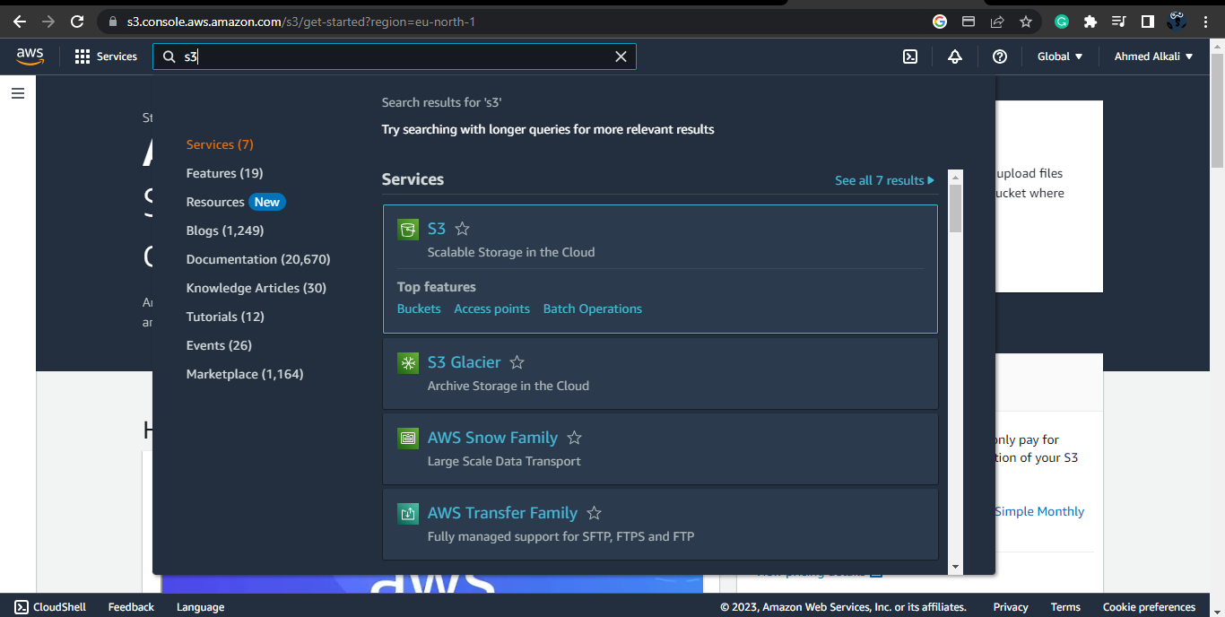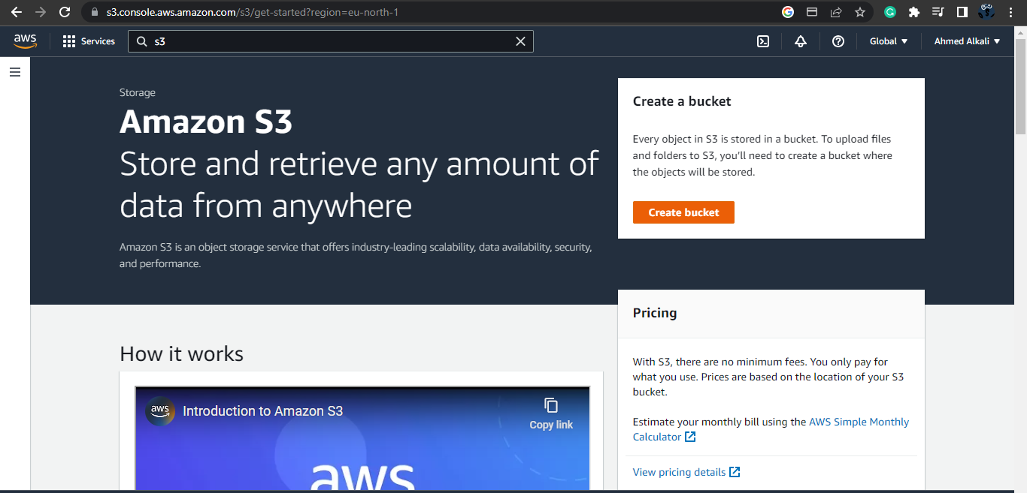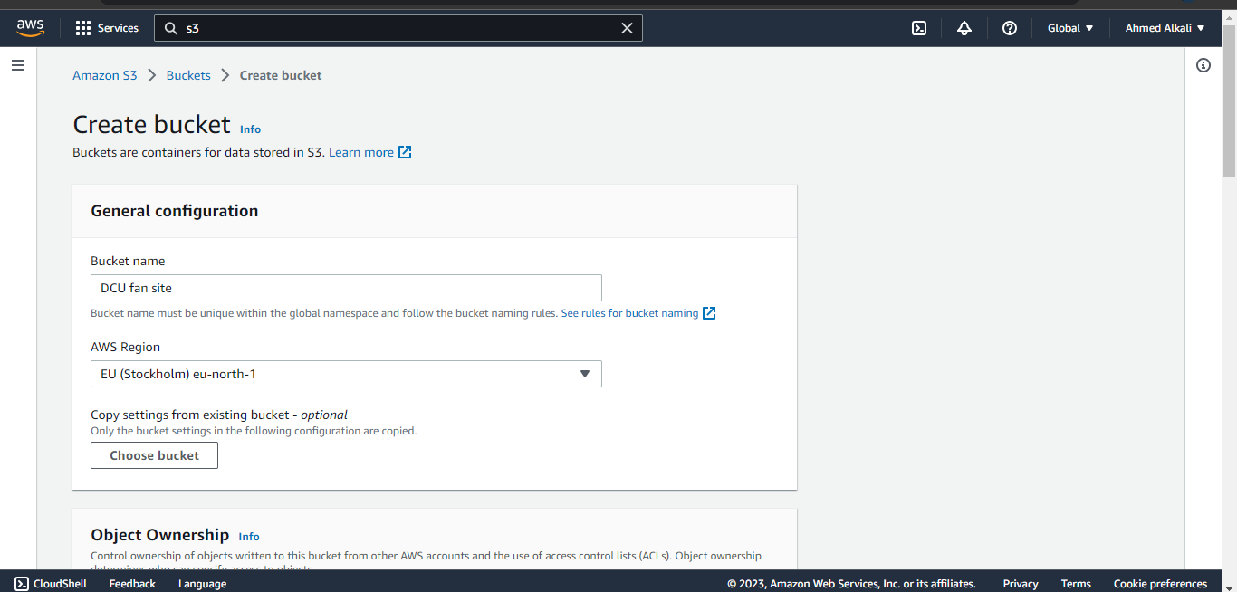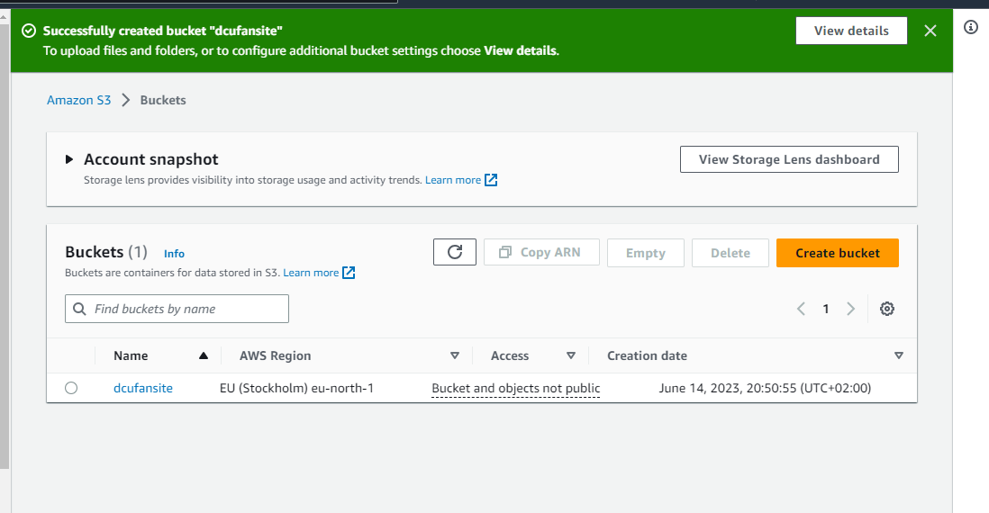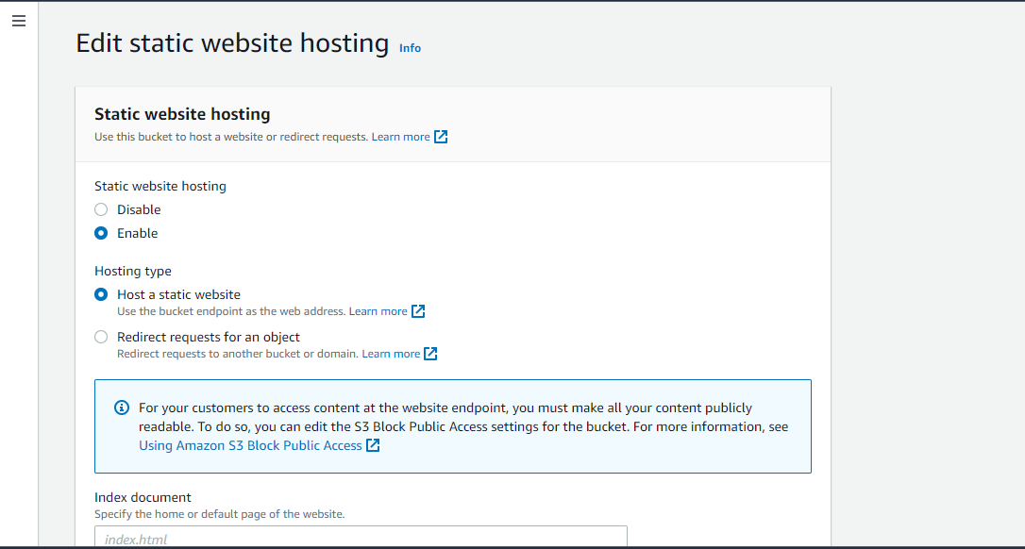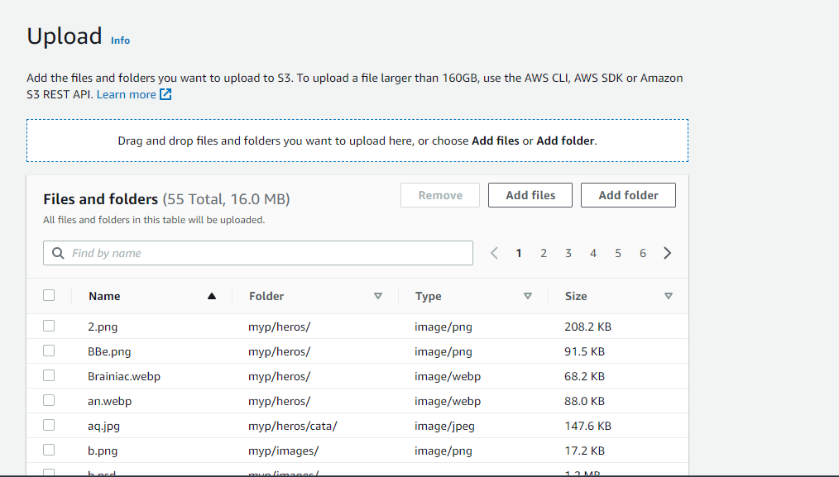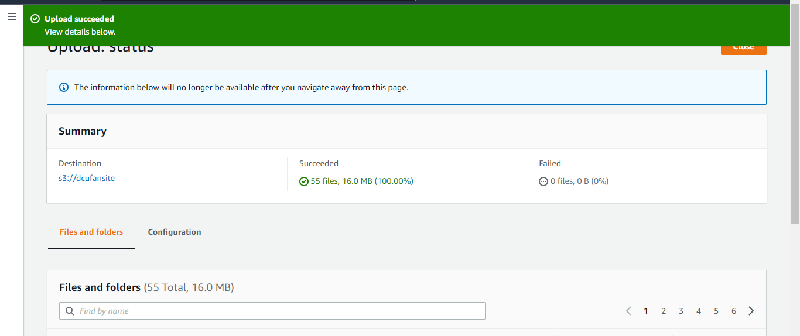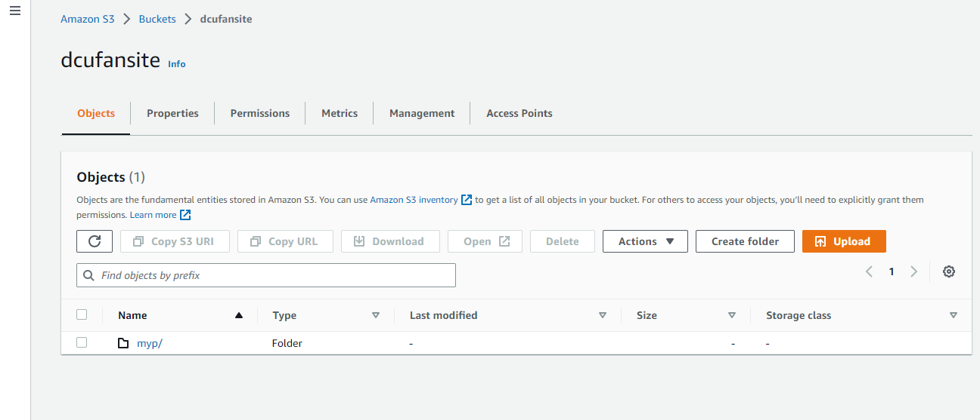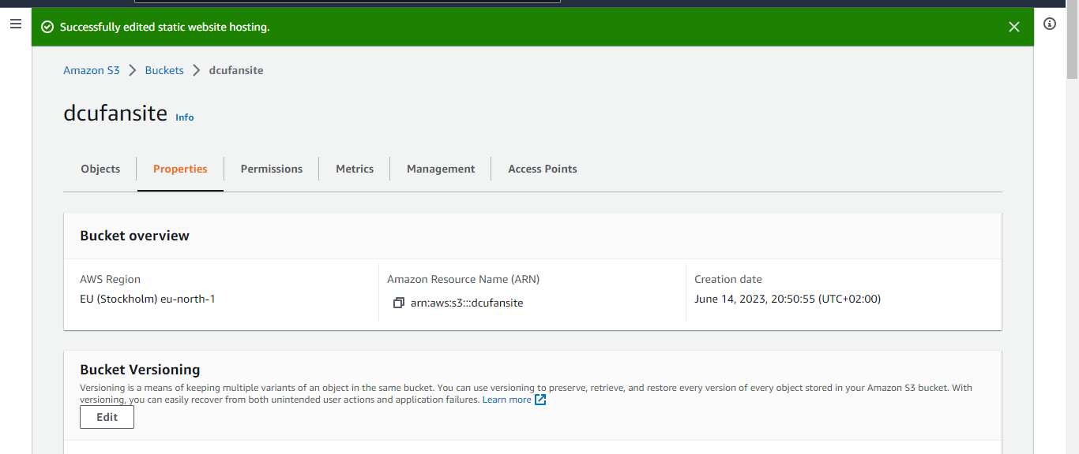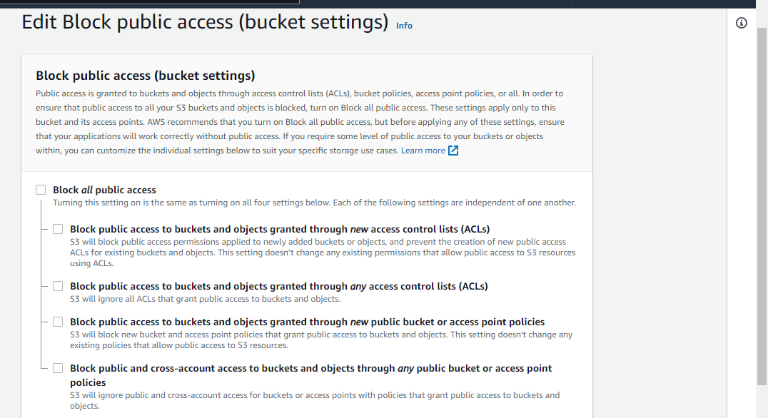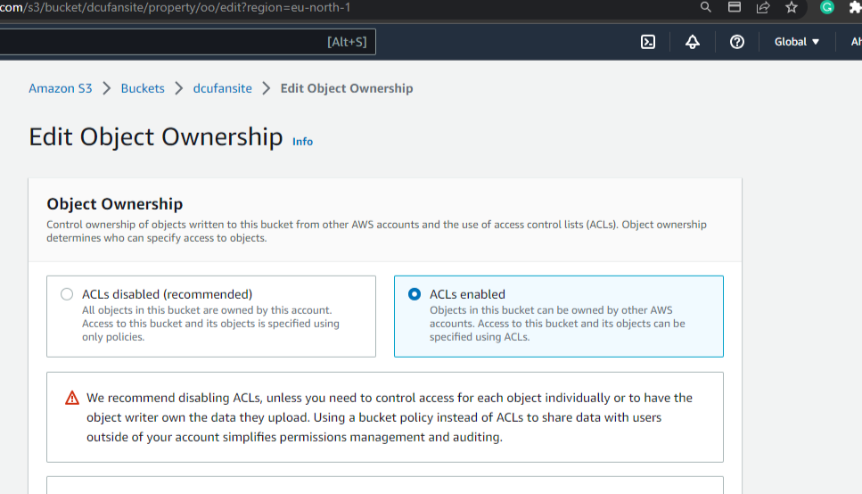

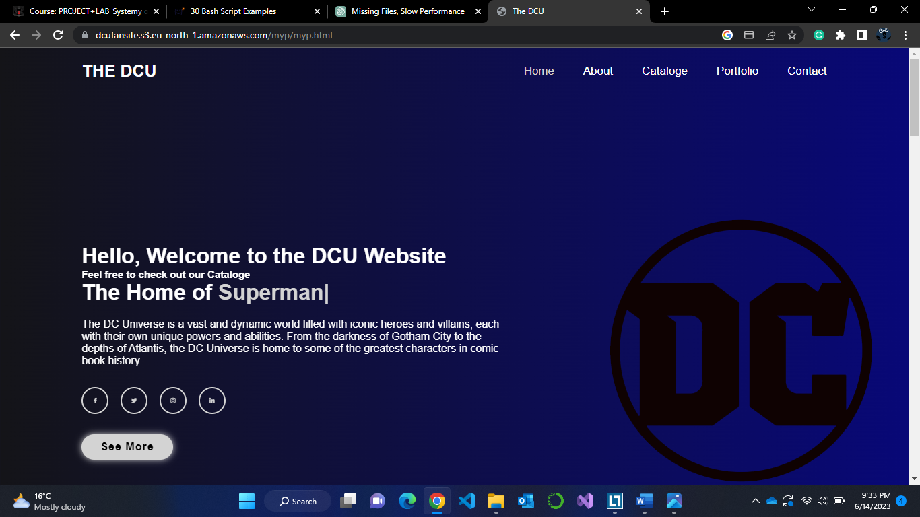

## DESCRIPTION OF THE TECHNOLOGIES USED

1. AWS: AWS stands for Amazon Web Services. It is a comprehensive cloud computing platform provided by Amazon. AWS offers a wide range of cloud services and products, including computing power, storage, databases, machine learning, analytics, networking, developer tools, and more. These services are designed to help individuals, businesses, and organizations build and deploy various types of applications and services in a flexible, scalable, and cost-effective manner.
2. AWS S3: Amazon Simple Storage Service (Amazon S3) is a highly scalable and durable cloud storage service offered by Amazon Web Services (AWS). It provides a secure and reliable way to store and retrieve any amount of data from anywhere on the web

**LITERATURE**

1. AWS
2. AWS S3